Major Changes from CFL2 Essentials 2025.2.2 to 2026.1
New Features
Quality Central 2026.1 Support
The 2026.1 release for Essentials For ColorFlex L2 now works with EasyMatch Quality Central
Built in Essentials Updater
When connected to the internet, Essentials can now check for updates and download them for you. This feature is disabled by default, but available in system settings to check manually.
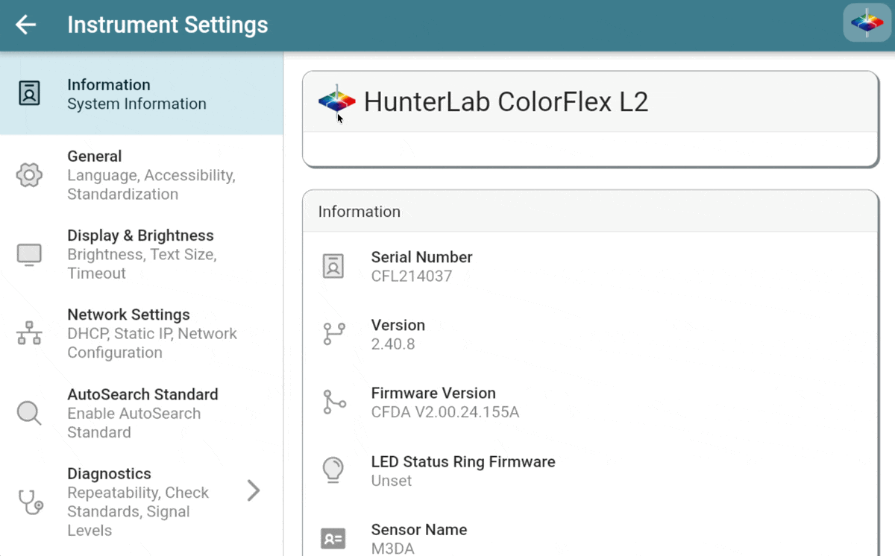
ColorFlex L2: Electronic Records
2D Chromaticity Tolerances (1578)
- Added chromaticity plot support to color plot view (1535)
Updated diagnostics messages to use notification dot instead of persistent banner (1469)
Other Changes
- Added french language support
- Allow absolute color plot on ezview (#2041)
- Updated spectral plot view layout and chart renderer
- Updated color plot with support for hue and chroma, easier point selection
- Added support for absolute color scale tolerances. Previously only difference tolerances could be added to color scale fields. (1600)
- Added support for spectral hitching of a hitch standard (1577)
- Added enhanced security settings with support for multiple users and a lock screen with timeout
- Improved printed sample labels to include tolerances and standard values
- Added diagnostic test for Coffee Tile in the Diagnostics page (1812)
- CFL2 Citrus and Tomato indices are now only available when setting the WorkSpace standard type to Hitch (1452)
- Updated WorkSpace revision logic to require a new revision (locking previous jobs) when changing and standard or tolerance values. Previously a new revision was only created when changing the standardization mode.
- Keyboard autocorrect has been disabled on all text fields (suggestions will still appear at the top) (1768)
- Sample notes and product ID fields are now disabled in the default WorkSpaces (1765)
- Sample averaging is now done spectrally instead of numerically (1679)
- Added BCU Color Index #1927
Bug Fixes
- Hitch offset is disabled for indices that are calculated in a different Illuminant/Observer (1761)
- CFL2 repeatability is now run at an 8 second interval (1709)
- Data View status bar no longer overflows in languages with longer display names (1727)
- The pass/fail values on the diagnostics page should now update correctly on the first run of diagnostics (previously it would stay blank) (1817)
- Improved ER event log pdf export performance
- Updated vista measure and standardize timeouts to 60 seconds to prevent any serial timeout problems
- Fixed an error when deleting a workspace
- Fixed the EZView and Color Data Table editors not expanding the precision picker correctly
- Updated color plot to show pass/fail for all indices (including chroma. tolerances)
- Color plots now default to absolute for Yxy (#2042)
- Fixes to event logger, handling bad logs for event Log pdf

Major Changes from CFL2 Essentials 2025.2.1 to 2025.2.2
Release 2025.2.2 -- EasyMatch Essentials for ColorFlex L2, Aug 2025
- Latest Spanish translations have been merged (1674)
- Camera initialization changes to ensure the sample camera is set up
immediately on launch (1674)
- Fixed an issue with the Data Management page not allowing imports of
Jobs or WorkSpaces (1676)

Major Changes from CFL2 Essentials 2025.2 to 2025.2.1
- Fixed an issue with the PDF export where standard values and differences weren't showing when using a working standard (1550)
- Fixed an issue with CSV exports multiplying spectral values incorrectly (1564)
- Fixed an issue with XLS exports not handling the standard spectral fields the same as sample. (1555)
- Fixed an issue with XLS exports having columns shifted (1555)
- Fixed an issue with XLS exports where difference values were being calculated for the standard, they should now remain blank (1555)
- Changed CSV export to quote any fields when they contain the field delimiter character, preventing parsing errors (1564). This means if you're using a comma delimiter and comma decimal separator, the values will all be inside double quotes
- Updated the Lycopene index, the gain and bias fields will now work correctly in the lycopene calculation (1562)
- Fixed a bug where a hitch standard could get set in one of the default workspace without a way to remove it (1563)
- Fixed diagnostic job names being in UTC instead of local time (1582)
- Fixed the main procedure button and diagnostic warning banners not updating their text when changing language (1568)
- Added some missing translations to Localizely (1559)

Major Changes from CFL2 Essentials 2024.4.2 to 2025.2
- Instrument Global Search
A new global search tool has been added to Essentials. Using this tool, you can quickly find jobs or workspaces just by typing their name. You can find the new global search in the help menu in the upper right, or by swiping up with 3 fingers on any page.
- Measurement Label Printing
Individual samples can now be printed on supported labels directly from the instrument. Press the "Print Label" button in the measurement detail dialog to print. Additional options are available in your workspace settings to control the barcode and other format options of the label. Essentials Supports the Brother QL800 series printers. We recommend the following label sizes:
- 29x90 mm (Address Label)
- 62x100 mm (Shipping Label)
- 62 mm width Roll (Shipping Label continuous)
- Workspace Barcode Automation
A new workflow has been added to Essentials that makes it even easier to switch workspaces. You can now print a unique barcode for any WorkSpace and scan it to immediately switch to that workspace. Now instead of using the UI on the instrument, you can print out a book of your WorkSpaces and just scan them to switch.
If you have a label printer connected to your instrument, you can even print the WorkSpace barcode directly from Essentials.
- Full Page Job Printing
In addition to PDF Exports, you can now print a Job to a networked printer directly from your ColorFlex L2. All measurements in the job will be printed out, matching how you've configured your color data or spectral data tables.
- PDF and XLS Job Exports
Jobs can now be exported in more than just CSV format. PDF and XLS formats are now available and make it easy to open jobs in Excel or to print reports in a preset format. If you're opening a Job in Excel, we strongly recommend using the XLS export as it will better format numbers and dates. The CSV export remains and is recommended if you're providing the Job to any sort of automation system.
When exporting a PDF, you can select either the color data table or spectral data tables to export.
- AutoSearch Standards
AutoSearch For Standard has been added as a system level option, allowing your sample to be matched to any WorkSpace based on its tolerances.
Once enabled, AutoSearch will show any WorkSpace where all the tolerances pass for that sample. If multiple WorkSpaces match, you'll be allowed to pick which one your sample is saved to.
If no WorkSpaces pass for this sample, you'll still be able to save the sample to the new "No Match" WorkSpace for later review.
Only WorkSpaces with Physical, Numeric, or Hitch standards will be included in AutoSearch. Your WorkSpace must also have at least one tolerance applied. If you want to exclude a WorkSpace from AutoSearch, you can always exclude it in the WorkSpace settings page for that WorkSpace.
- Custom Diagnostic Target Reset Option
When standardizing in a mode other than the 1" port plate, Essentials will automatically record custom green tile targets for that standardization mode. This is done the first time you standardize in that mode and present the Check Tile. In the event that this target is incorrectly set, you can now reset it in diagnostics.
The next time you standardize in any of the reset modes and measure the Check Tile, a new target will be set. Note that this does not apply to the 1" port plate targets, only the Custom and Sample Cup modes are resettable.
- Move Jobs Out of Default WorkSpaces
One bit of feedback we received was that jobs created in the default workspaces can be hard to work with since they cannot be modified. If you take a measurement in that workspace and want to later view differences or indices, well, you can't. An option has been added when you try to edit a default workspace to move the existing jobs to your new workspace. This allows those measurements to be manipulated, but keeps the defaults locked and in a known state.
The checkbox to move jobs to a new WorkSpace will only appear when doing a save-as from one of our default workspaces. This is the only time a job can be moved between WorkSpaces on the instrument.
- ColorFlex L2 Citrus
ColorFlex L2 Citrus is now supported with a license key. Once enabled, ColorFlex L2 Citrus will show a new Citrus WorkSpace with CR, CY, and CN indices enabled. Like ColorFlex L2 Tomato, this new WorkSpace will walk you through hitching to your Citrus Standard.
- Standardization and Diagnostics Illustrations
To keep things clear and simple, new illustrations have been added to the standardization and diagnostics prompts. These illustrations make it easy to know exactly how the instrument should be configured, no matter your language. These diagrams are dynamically assembled by Essentials, so the correct combination of port plate and tile will always be shown for your selected standardization mode.
- Pass/Fail Logic Changes
The pass/fail indicators on EZ View and the Color Data Table are now hidden if no tolerances are set. Previously, we would show "pass" if no tolerances were set.
- Sample Camera Improvements
The sample camera now has a fixed white balance and exposure, making samples look much more accurate and consistent. We'll be tweaking these parameters over time, so please let us know if any samples look incorrect in the camera preview.
- Other notable changes
- The "Setup Hitch" text now has a higher priority than the "Standardize" text on the main action button. Pressing "Setup Hitch" will still trigger standardization before the hitch wizard launches.
- The floating back button is now turned on when entering system pages like print settings or file pickers
- Historical diagnostic targets are now preserved. If the targets are reset or changed, the new values will not affect prior diagnostic results
- Updated Hitch wizard text, "Hitch To Tile" is now "Hitch to Standard" to better include hitch standards like the OJ tube
- The jewel button in the top right now shows the drop-down that used to be triggered by a long press. This menu now contains a link to the help overlay, screenshot, screen record, and global search functions
- Files are now fully written to the connected flash drive before the finish message is shown on screen. This means it should always be safe to unplug the flash drive when the instrument says an export is complete.
- Notes and Product ID should now be available on the CSV and XLS exports CSV and XLS export file names now include the WorkSpace name to avoid file name collisions.
- The "Shutting Down" screen that appears when disconnecting power is now much larger. You must still wait for that screen to go away before turning your instrument back on, it's just easier to see now.
- When enabling ColorFlex Citrus, the screen will now automatically change orientation
- An option to create a backup has been added to the "Install Update" dialog. We encourage all customers to create a backup to a flash drive before installing an update.
- When exporting diagnostic Jobs as PDFs, the color data table export layout will always be used
- The inactivity detector has been updated to work on dialogs and the internal tools pages. This should mean that the screen wont get stuck being dim while a dialog is open.
- The Button Procedure system has been fully overhauled. This system is responsible for any measure/standardize/average/diagnostic button you see in Essentials, and had some fundamental issues causing it to not always show or do the right thing. This refactor should resolve all the cases where a button is stuck saying "Standardize" or otherwise behaves in an unexpected way.
- When exporting a job from the job list, you'll now be returned to the data views instead of staying in the export dialog
- D65/2 option has been added to YI E313, WI E313, and Tint indices
- Dramatically improved the start up time of Essentials after the instrument has booted. This means there's less time sitting at the homescreen after boot up, instead the app launches immediately.
- Added Citrus Tube to standardization mode options on CFL2 Citrus
- Added instructions to use 1" port plate during standardization if using citrus tube
- If all prompts are disabled in the WorkSpace Settings (Sample Name, Product ID, etc) then the measurement will immediately be taken when pressing the measure button
- Shade Sorting Number has been added as an index
- Favorited WorkSpaces are now indicated on the WorkSpace list with a star. The are also sorted to the top of the list, after the currently launched WorkSpace
- Merged the latest translations from Localizely as of 2025-04-22, the current list of supported languages is as follows: English (US)

  - German
  - Chinese Simplified
  - Chinese Traditional
  - English (GB)
  - Thai
  - Spanish
  - Japanese
  - Italian (IT)
  - Czech (CZ)
  - Hungarian (HU)
  - Polish (PL)
  - Portuguese
  - Turkish
  - Russian (RU)
  - Korean
  - Indonesian
  - Dutch

- Bug Fixes 2025.2
- Fixed a bug where the sample name would be reset when showing the sample preview (#1408)
- Fixed a number of bugs with auto-export fields not populating correctly (#1406)
- XLS exports now work correctly for numeric standards (#1400, #1399)
- Fixed an issue where hitch settings weren't being applied correctly when set with the main action button (#1395)
- Fixed a bug where the average measurement dialog would always scroll to the bottom, even when it had finished taking measurements (#1354)
- Fixed an error when Hitching in XYZ
- Fixed strength indices showing an empty configuration dialog when being enabled
- Fixed a bug where the averaging dialog was reordering rows as measurements were taken
- Added support for recovery app installation using the .hunterlab files
- Enabled global search by default
- Fixed tolerances being rounded to values lower than what the user entered on the CDT
- Fixed a bug where hitch as-read measurements were prompting for sample name (#1267)
- Fixed a bug where setting a hitch in a workspace with continuous measurement enabled would result in the as-read hitch measurement being taken continuously with no escape
- Fixed the Check Tile prompt not appearing in CFL2 standardization (#1273)
- The export button in the internal tools signal level page will now activate correctly when plugging in a flash drive and taking a measurement (or reading any signal levels) (#1246)
- Workspace favorites are now correctly sorted to the top of the list of workspaces (#1296)
- Exporting both a job PDF and sample images will no longer get stuck with a permanent loading spinner (#1302)
- Fixed a bug where Strength indices were not being calculated
- Fixed a bug where check tile targets were getting cleared when doing a customer data reset. Diagnostic targets will now remain between customer data resets.
- Fixed a bug where you could get stuck in the help overlay, unable to interact with Essentials until power cycling the instrument. (#1081)
- Fixed a bug where the average read count was being used for automatic mode, even if automatic mode did not have a limit set. (#1161)
- Fixed Static IP addresses not being show in the Instrument Information page
- Fixed not being able to switch back to DHCP when setting a static IP

Major Changes from CFL2 Essentials 2024.4.1 to 2024.4.2
- Fixed a bug where the help overlay wasn't saving that it had already been viewed (#1169)
- Changed the behavior on initial sensor connection. It will now retry by fully closing and reopening the serial port (#1168)
- This should address the "Serial Timeout" errors that are seen when the instrument powers up
- Corrected the Opacity calculation to use the right black/white measurements (#1170)
- Added additional logging to standardization, soft shutdown trigger, and diagnostics events
- Updated Diagnostics Full Database Export to copy the existing app database to a flash drive for debugging
- Made Gateway and Preferred DNS fields optional when setting a static IP (#1171)

Major Changes from CFL2 Essentials 2024.4.0 to 2024.4.1
- Fixed a bug with diagnostics showing "New Job" button instead of Standardize button (#1093)

